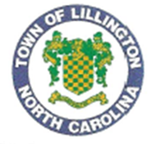**TOWN OF LILLINGTON**

**BANK DRAFT AUTHORIZATION**

This is to authorize the Town of Lillington to draw a monthly draft on my account for payment of water, sewer, and/or waste collection services on:

UTILITIES ACCOUNT NUMBER: __________________________________________

SERVICE ADDRESS:_____________________________________________________

CUSTOMER’S NAME: ___________________________________________________

BANK NAME: __________________________________________________________

BANK ACCOUNT NUMBER: _____________________________________________

BANK ROUTING NUMBER: ______________________________________________

Drafts are drawn on the 10th of every month unless the date falls on a weekend or holiday; then the drafts will be processed the next business day.

START DATE: _______________________________

SIGNATURE: _______________________________

DATE: _____________________________________

Please return this signed form along with a **VOIDED CHECK**.

Please notify your bank that you have authorized us to draft your account. Return to:

**Town of Lillington**

**Attn: Mary Tart**

**PO Box 296**

**Lillington, NC 27546**